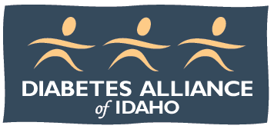
Nominate yourself or a colleague to be added to the candidate pool for future elections for the Diabetes Alliance of Idaho Board of Directors. Nominations will be kept on file for three years. Submission of nomination does not guarantee election to the board. Board positions are not compensated.

Diabetes Alliance of Idaho
Board of Directors Nomination Form

Nominee Name: ___________________________________________________________________________

Preferred Mailing Address: _______________________________________________________________

City: ___________________________________ State: ________________ Zip: ______________

Preferred phone: ________________________________________________________________________

Preferred Email: __________________________________________________________________________

Are you a current DAI member? _____ If applicable: Credentials: ____________________________

Employer/Company Name: _________________________________________________________________

Job Title: ________________________________________________________________________________

Business Address: _____________________________________________________________________________

City: ___________________________________ State: ________________ Zip: __________________

Area of professional expertise and/or personal interest: check all that apply:
□ Public Health □ Public Policy □ DPP □ DMSE □ Education/Educator
□ Nonprofit □ Medical Profession □ Insurance □ Pharmacy □ Social Media/Web
□ Accounting □ Media Relations □ Membership □ Fundraising □ HR

Why are you interested in serving on the Diabetes Alliance of Idaho board or a committee?

List the other professional, nonprofit, or volunteer organizations in which you participate:

What volunteer or committee work interests you? ______________________________________________

Submitted by ____________________________________________________ Date _______________

